**Database System LAB Practical – 4**

**Tables:**

**Client Master**

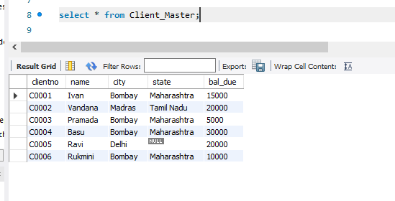

**Product Master**

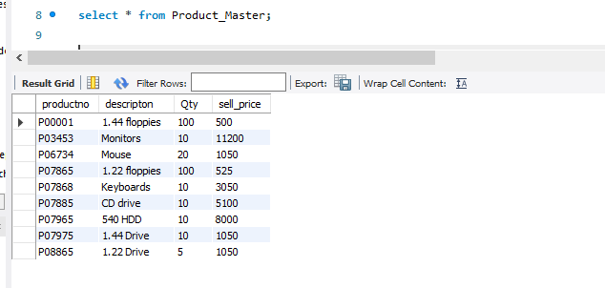

**Q-1 Find out names of all clients.**

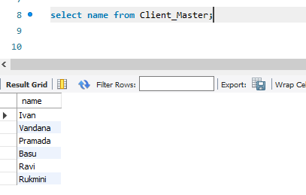

**Q-2 Find out names and cities of all clients.**

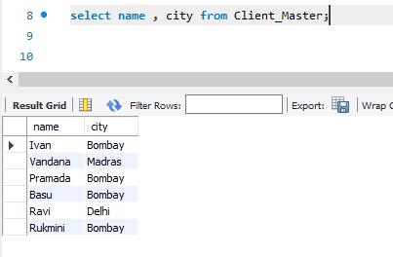

**Q-3 List the various products available from the product master table.**

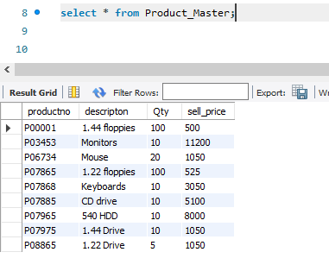

**Q-4 List all the clients located in Bombay.**

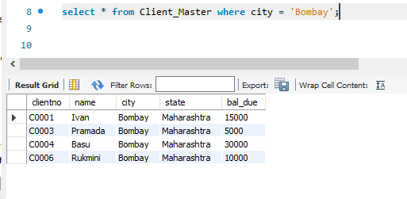

**Q-5 Display all the information for client no. C0001 and C0002.**

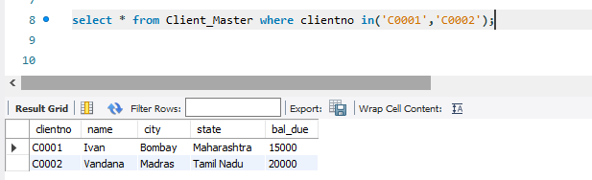

**Q-6 Find the products with description as ‘1.44 Drive ‘and ‘1.22 Drive’.**

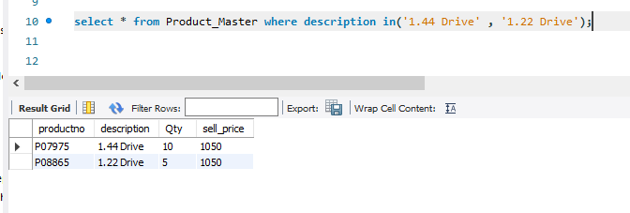

**Q-7 Find all the products whose sell price is more than 5000.**

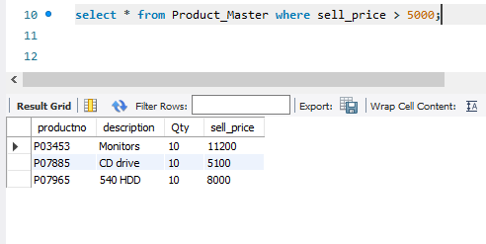

**Q-8 Find all the products whose sell price is more than 2000 and less than equal to 5000.**

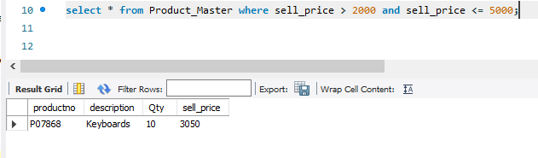

**Q-9 List the name, city and state of those clients not living in ‘Maharashtra’.**

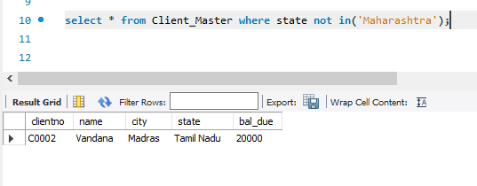

**Q-10 Change the city of client no. C0005 to Bombay.**

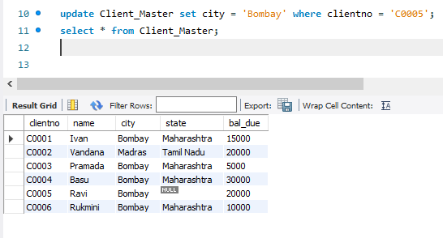

**Q-11 Delete all the details of product where Quantity is 100.**

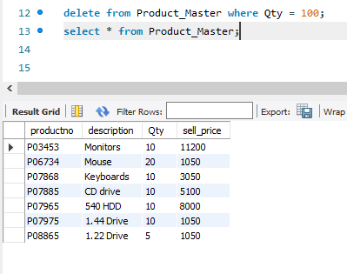

**Q-12 Add a column Telephone in client with domain number (10,0) and add values.**

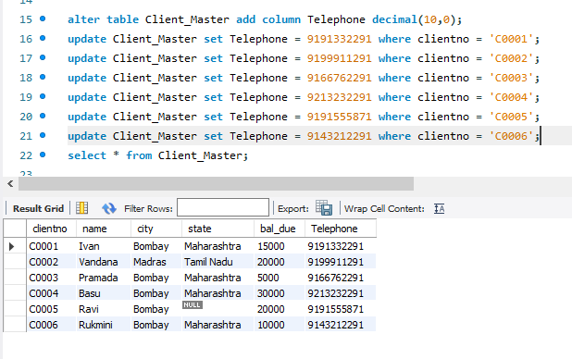

**Q-13 Change size of sell_price to (10,2).**

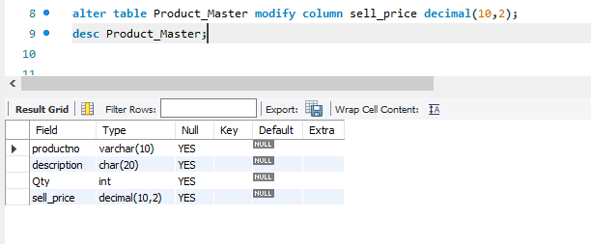

**Q-14 Find out the names of the clients with names containing ‘a’ as second letter.**

